Children's Author David Ira Rottenberg
Is Visiting!
Inspire lifelong readers with a personalized autographed book!

Dear Parents--Well-known picture book author David Ira Rottenberg is visiting Feinberg-Fisher K-8 Center on Feb. 22nd. Accompanying Mr. Rottenberg will be dancers from The InMotion Performing Arts Center. Together, they are putting on a reading/performance of Mr. Rottenberg’s book, Gwendolyn, the Graceful Pig. Following the reading/performance, Mr. Rottenberg will autograph books. If you'd like to purchase an autographed book for your child, please return this order form with your payment.

Gwendolyn, the Graceful Pig tells the tale of Gwendolyn and Omar—two best friends who have big dreams. Gwendolyn longs to dance, and Omar wants to join the football team. There’s just one problem—they’re both pigs! How will Natasha Levertov, “the greatest teacher of dance in ze vorld,” help them make their dreams come true?
Adorable illustrations and charming text make this story a hit with girls and boys. It’s not just for aspiring dancers but shows all children the joy of pursuing what they love.
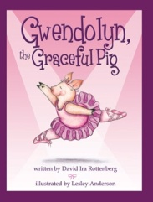
Price: $15.00 Quantity:______ Make check payable to David Rottenberg:______________________________
ORDER DUE DATE: _____________________________________________________________________________
Student's Name:_______________________________________________________________________________
Student's Name:_______________________________________________________________________________
Student’s Teacher:_____________________________________________________________________________
Additional book purchase and autograph instructions:________________________________________________
____________________________________________________________________________________________

